

eMedrep Application

Software Documentation



**DOCUMENTATION ON EMEDREP APPLICATION**

**Table of Contents………………………………………………………………………………………………….**1

1. Introduction2

1.1 Purpose2

1.2 Scope2

1.3 Overview2

1. Modules/Use Cases3

2.1 Actors3

2.2 Module Flowcharts/Use Case Diagrams 5

1. Design Overview21

3.1 Introduction21

3.2 System Architecture21

3.3 System Interface21

1. System Object Model36

4.1 Introduction36

4.2 Subsystems and Interfaces36

1. Object Collaboration 37

6.1 Object Collaboration Diagram37

1. Data Design38

6.1 Entity Relationship Diagram38

1. Functional and Non-Functional Requirements39

7.1 system Functional Requirements39

7.2 Non-Functional Requirements39

1. Security43
2. **Introduction**

The Software Design Document is a document to provide citations which will be used to aid software development by providing the details for how the software should be built. Within the Software Design Document are narratives and graphical documentation of the software design for the project including use case models, sequence diagrams, collaboration models, object behavior models, and other supporting requirement information.

**1.1 Purpose**

The purpose of the Software Design Document is to provide a description of the design of a system fully enough to allow for software development to proceed with an understanding of what is to be built and how it is expected to be built. The Software Design Document provides information necessary to provide description of the details for the software and system to be built.

**1.2 Scope**

This Software Design Document is for a base level system which will work as a proof of concept for the use of building a system that provides a base level of functionality to show feasibility for large scale production use. This Software Design is focused on the base level system and critical parts of the system. For this particular Software Design Document, the focus is placed on generation of the documents and modification of the documents. The system will be used in conjunction with other pre-existing systems and will consist largely of a document interaction facade that abstracts document interactions and handling of the document objects.

**1.3 Overview**

The Software Design Document is divided into 11 sections with various subsections. The sections of the Software Design Document are:

1. Introduction
2. Modules/Use Cases
3. Design Overview
4. System Object Model
5. Object Collaborations
6. Data Design
7. Non-functional Requirements
8. Supplementary Documentation
9. **Modules/Use Cases**

**Use-Case Model Survey**

**2.1. Actors**

**2.1.1 Administrative User**

The Administrative User is a user who oversees the accounts creation and management and as well monitors activities on the portal, retrieves report, check order history and populate features.

**2.1.2 Manufacturers**

Manufacturers are the group of pharmaceutical companies who are the first contact of drug distribution. They are usually classified as manufacturers due to the volume of business that they do per transaction. They either manufacture drugs or import. Some import, brand and distribute as their product or whilst others just import and distribute for multinational companies. Commonly, we find some that do all three.

**2.1.3 Distributors**

These are companies that do distribute drugs on behalf of the manufacturing companies. Usually they deal with rare prescription drugs that cannot be easily purchased in the market and specialty drugs such as IVF drugs, Cancer management drugs and Diabetes management medications. They usually do not deal with too many products but usually have to lots of a particular product within a short period of time as margins are usually low.

**2.1.4 Wholesale Pharmacist(s)**

These are pharmaceutical companies or bodies that liaise with hundreds of manufacturers, importers and distributors. Their value proposition is that they deal with so many suppliers so the Retail Pharmacies don’t have to. They usually act as distributors for particular products or companies.

The Wholesale Pharmacist(s) can:

1. Register Retail Pharmacist(s) under them;
2. Upload inventories or Create products;
3. Set prices for Order Requests;
4. Negotiate and Approve Orders;
5. Create contracts;
6. Send messages to Retail Pharmacist(s);
7. Retrieve distribution data.

**2.1.5 Retail Pharmacist(s)**

Retailers denote the companies and institutions that distribute or dispense drugs directly to the end users. The retail-wholesale bloc deals with relatively smaller volumes per transaction (N15, 000 – N1.5m) and involves more individuals and is closest to the end user.

1. The Retail Pharmacist(s) can:
2. Sign up on their own;
3. Create Orders;
4. Manage inventories;
5. Negotiate and Accept Contracts;
6. Browse for new products and promotions;
7. Search through records of sales;
8. Send message to Wholesale Pharmacy registered to;
9. View approved sales in real time.

Retailers can be classified into the following:

* Chain Retail: These are retail stores who have more than one physical premises for transacting business.
* These are Retail stores that have just one large premises and more than 3 employees.
* Mini Retail: These are pharmacies with a relatively small premises. They are usually owned and run by a pharmacist, an employee and/or relations. It is also common to find them inside supermarkets.
* Patent Medicine Stores/Chemists: These are stores that are licensed to sell drugs but since are not owned or run by a pharmacists are heavily restricted on the kind of drugs the sell.
* Hospital Pharmacies: These are pharmacies run by the resident pharmacist in a particular hospital.

**2.1.6 Logistic Companies**

**2.2 Module Flowcharts/ Use-Case Diagrams**

**The Wholesaler/Supplier Module**

**2.2.1 The eMedrep CRM Network Use-Case**

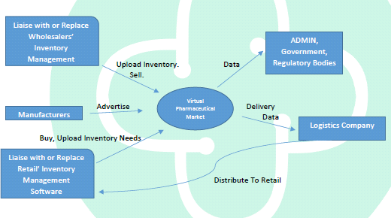

**Fig 2.1** Players in the eMedrep CRM Network

**2.2.2 Workflow for Wholesale Pharmacies(s)/Supplier(s)**

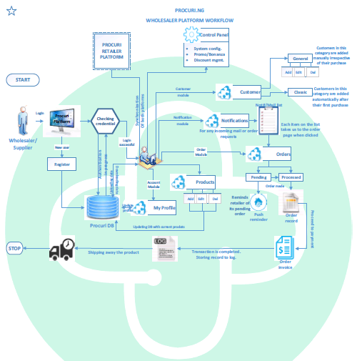

**Fig. 2.2** Wholesaler/Supplier Platform Workflow

**2.2.3 Overview of the Design Process of eMedrep for Wholesale Pharmacies/Suppliers**

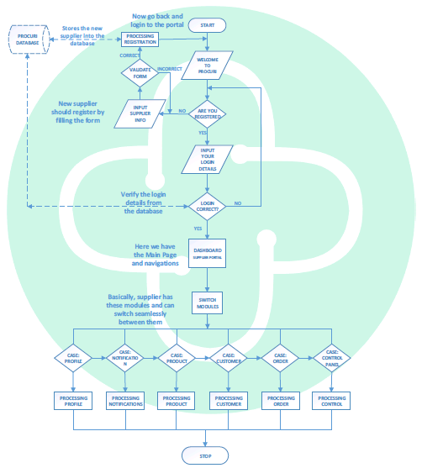

**Fig. 2.3** Wholesaler/Supplier Overall Flowchart

**2.2.4 Wholesaler/Supplier Profile Module**

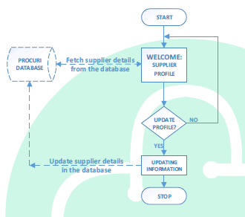

**Fig. 2.4** Wholesaler/Supplier Profile

**2.2.5 Wholesaler/Supplier Product Module**

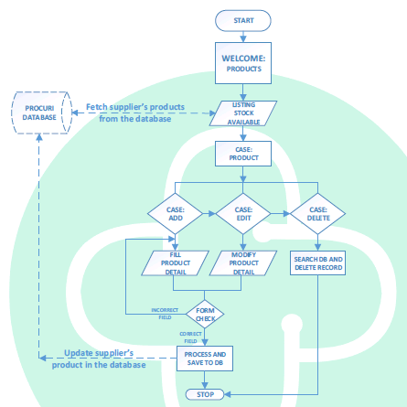

**Fig 2.5** Wholesaler/Supplier Product Module

**2.2.6 Wholesaler/Supplier Notification Module**

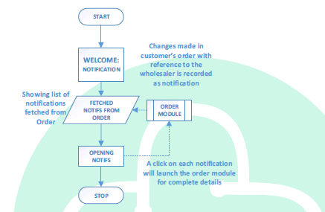

**Fig 2.6** Wholesaler/Supplier Notification Flowchart

**2.2.7 Wholesaler/Supplier Order Module**

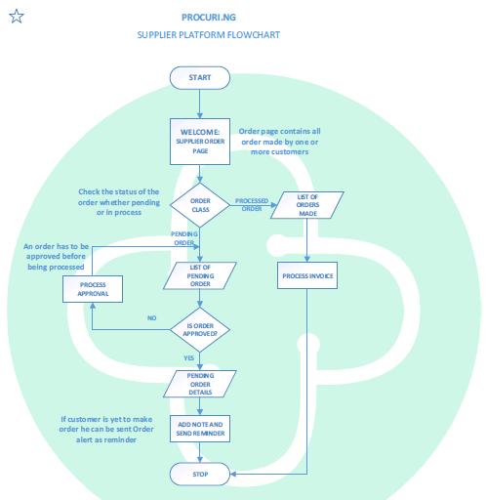

**Fig. 2.7** Wholesaler/Supplier Order Flowchart

**2.2.8 Wholesaler/Supplier Customer Module**

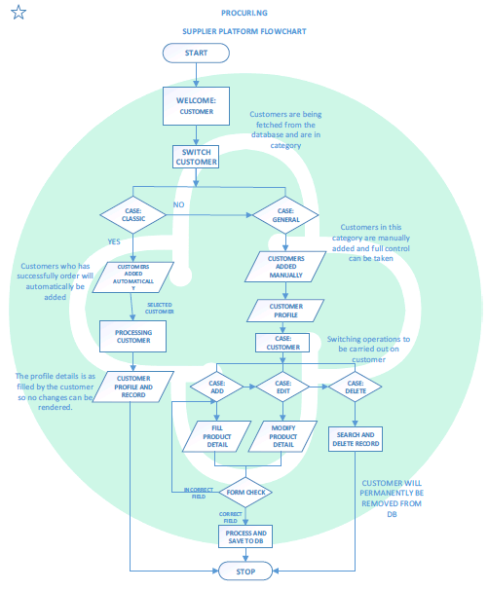

**2.8** Wholesaler/Supplier Customer Flowchart

**2.2.9** **Wholesaler/Supplier Control Panel Module**

Control Panel is an added module which will allow the Wholesalers/Supplier to do some advanced configuration with Administrative access. In this module, the Wholesaler/Supplier can do the followings:

* Activate “Bonanza/Promo” period for customers
* Manage the “Badges” available for customers e.g. Most Order badge and discount can be given to these ones on their subsequent purchase.
* Report for various transaction will be printed from this module
* Anything settings/configurations can be added to this module.

**The Retailer/Customer Module**

**2.2.10 Workflow for Retailer/Customer**

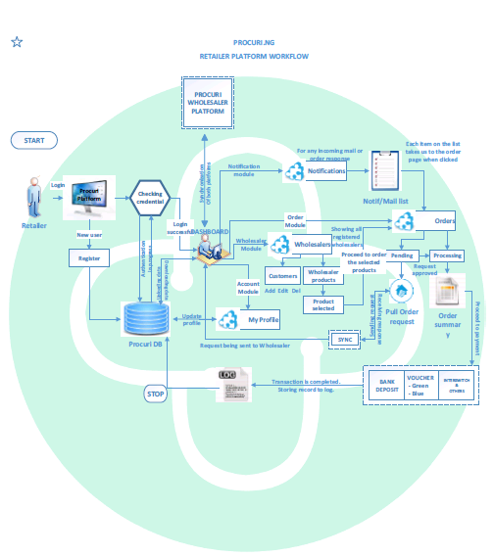

**Fig. 2.10** Retailer/Customer Module

**2.11 Retailer/Customer Design Process**

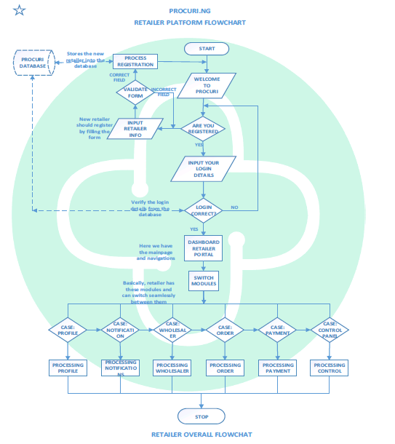

**Fig. 2.11** Retailer/Customer Overall Flowchart

**2.2.12 Retailer/Customer Profile Module**

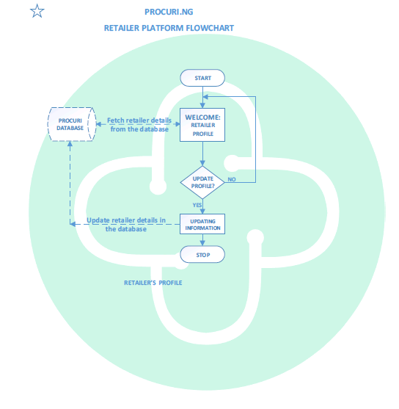

**Fig. 2.12** Retailer/Customer Profile Flowchart

**2.2.13 Retailer/Customer Notification Module**

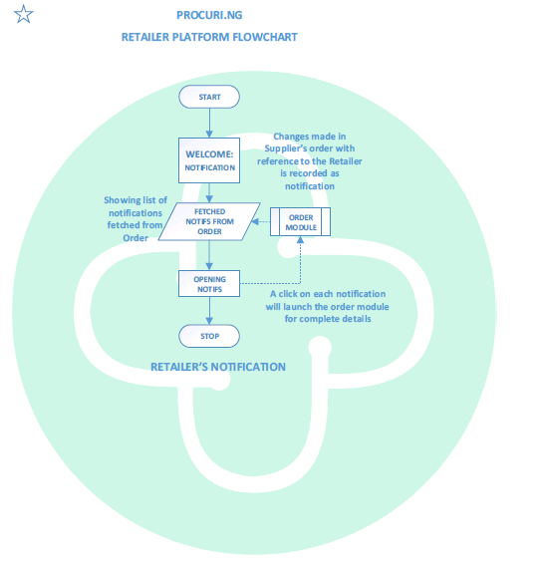

**Fig. 2.13** Retailer/Customer Notification Flowchart

**2.2.14 Retailer/Customer Client Module**

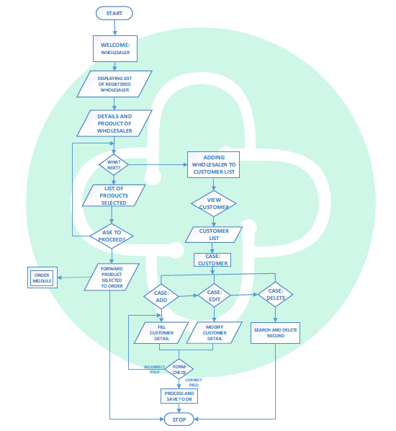

**Fig. 2.14** Retailer/Customer Client Flowchart

**2.2.15 Retailer/Customer Order Module**

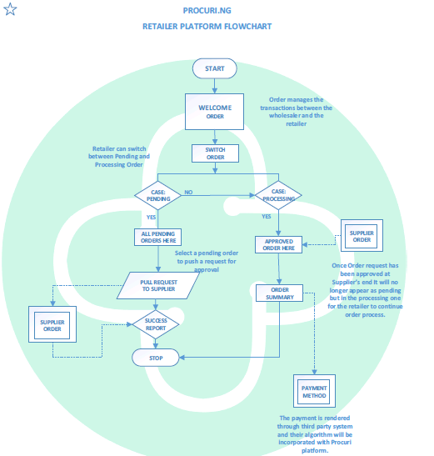

**Fig. 2.15** Retailer/Customer Order Flowchart

**2.2.16 Retailer/Customer Payment Process Module**

1. **Design Overview**

**3.1 Introduction**

The Design Overview is a section introduces and gives a brief overview of the design. The System Architecture is a way to give the overall view of a system and to place it into context with external systems. This allows for the reader and user of the document to orient themselves to the design and see a summary before proceeding into the details of the design.

**3.2 System Architecture**



**Fig 3.1** Overall Structure for the eMedrep CRM application

* 1. **System Interfaces**
     1. **External User Interface Requirements**
        1. User Interfaces
* The User Interface for the system will allow the user to easily navigate through the system. The user is presented with all main functions on the first user interface page to allow for the user to select the function to use without the need to navigate inward to find it.
* The interface also provides tab focus which alleviates stress on users’ arms and hands caused by changing constantly from keyboard to mouse.
* The interface will be accessible through a web interface allowing for centralized hosting and use by various Operating Systems.

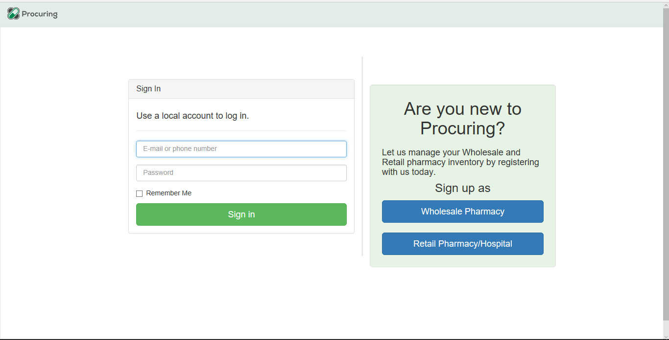

**Fig 3.2** Login Page

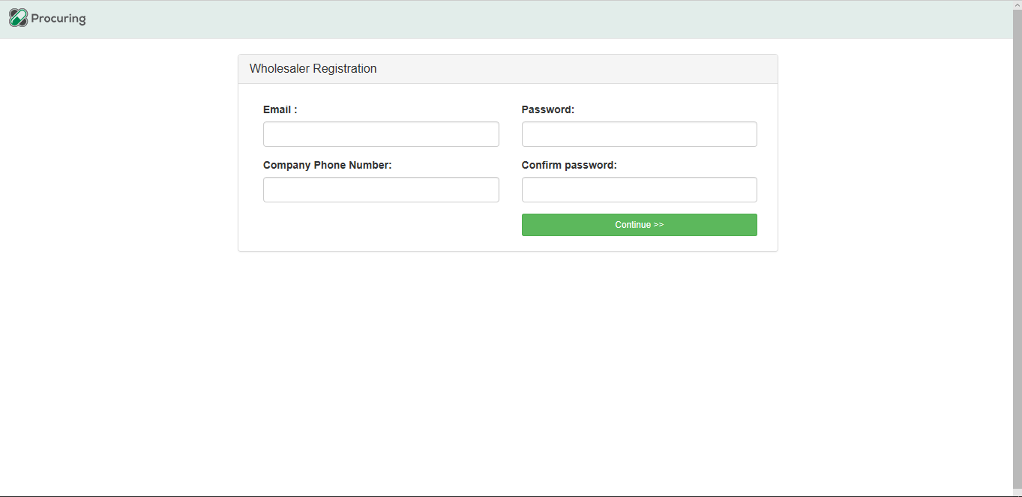

**Fig 3.3** Wholesaler/Supplier Registration Page

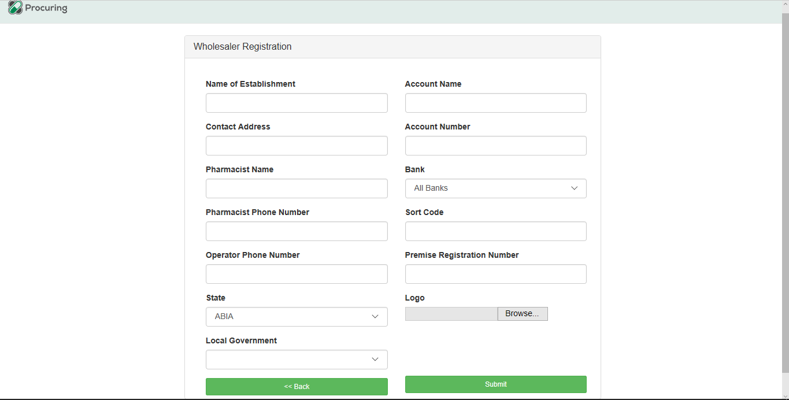

**Fig 3.4** Wholesaler/Supplier Registration Page Continued

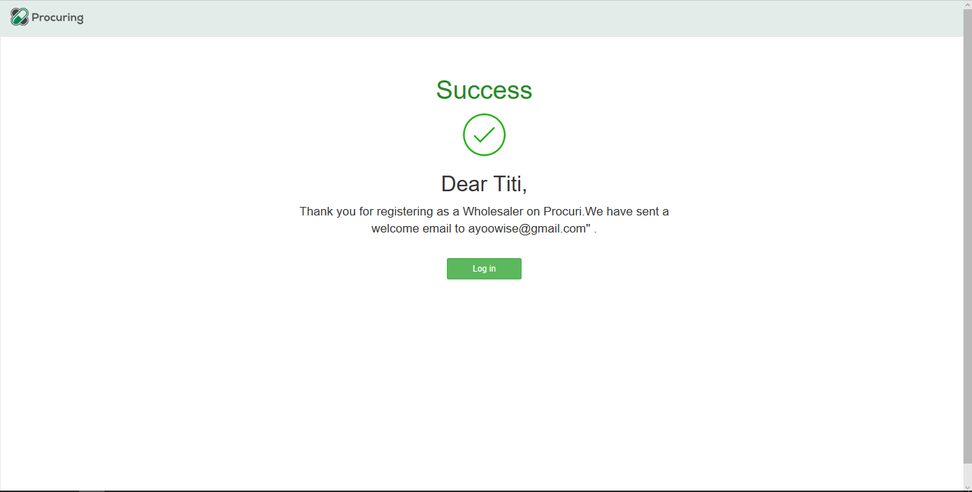

**Fig 3.5** Success Page

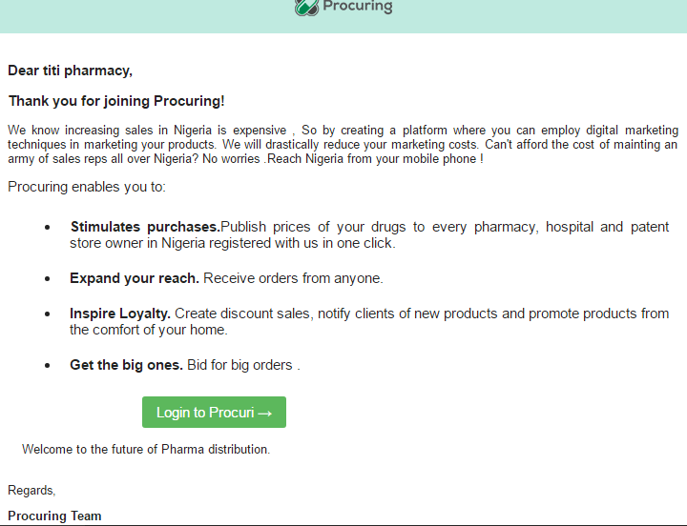

**Fig 3.6** Wholesaler/Supplier Welcome Page (Email)

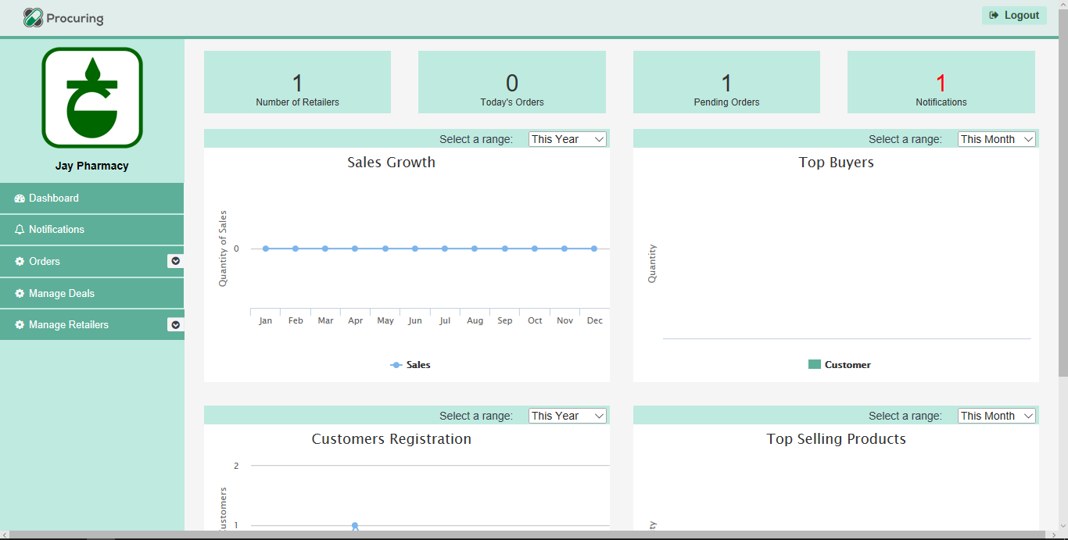

**Fig 3.7** Wholesaler Dashboard

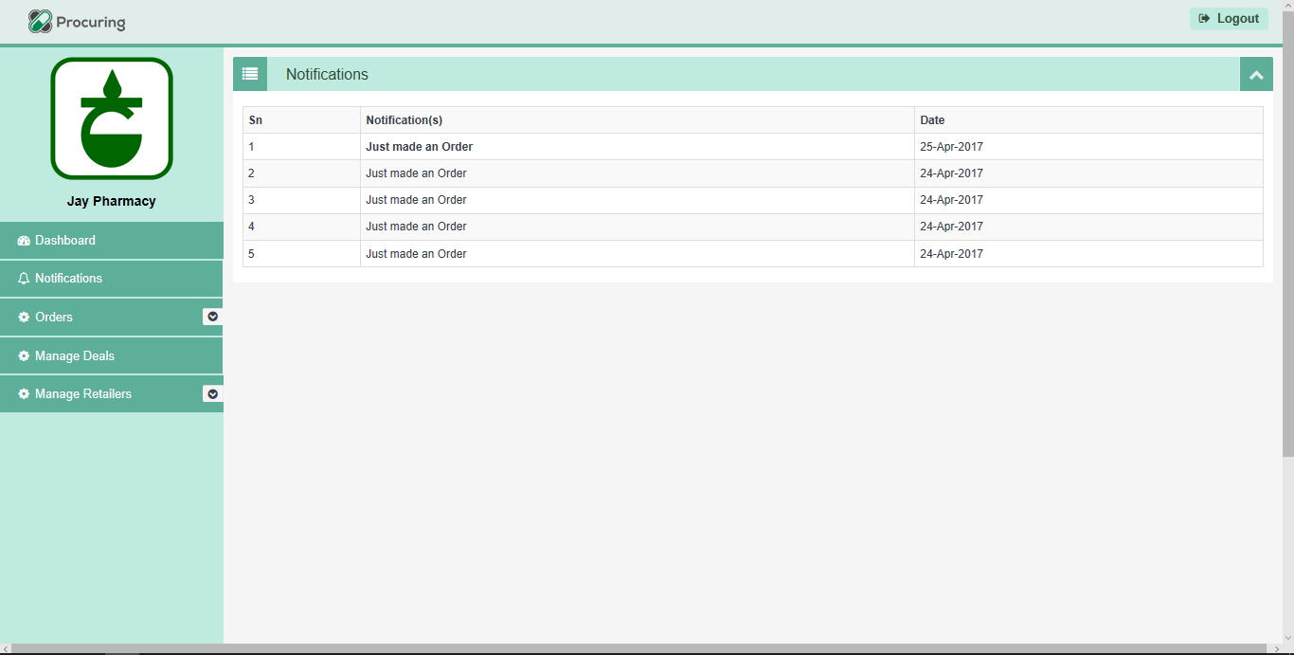

**Fig 3.8** Wholesaler/Supplier Notification Page

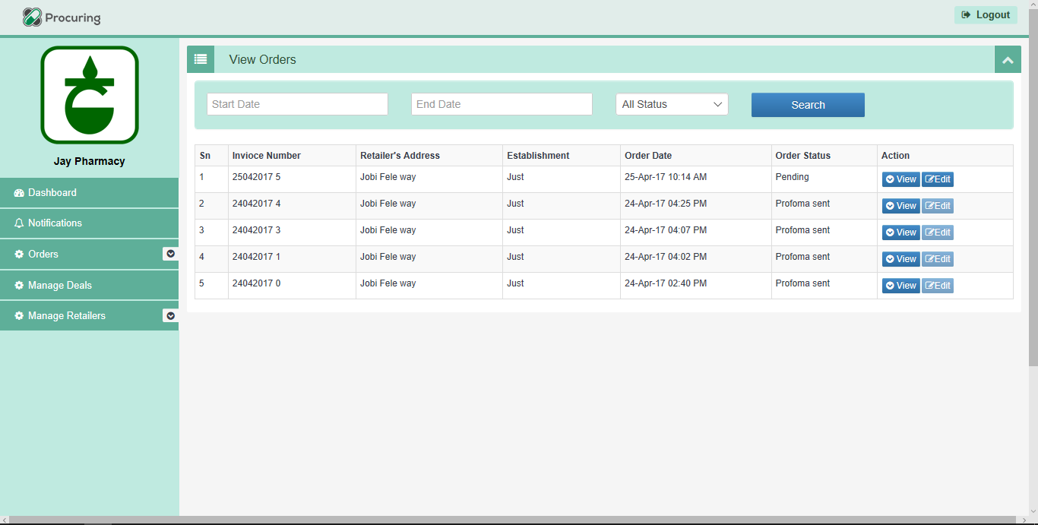

**Fig 3.9** Wholesaler/Supplier View Orders Page

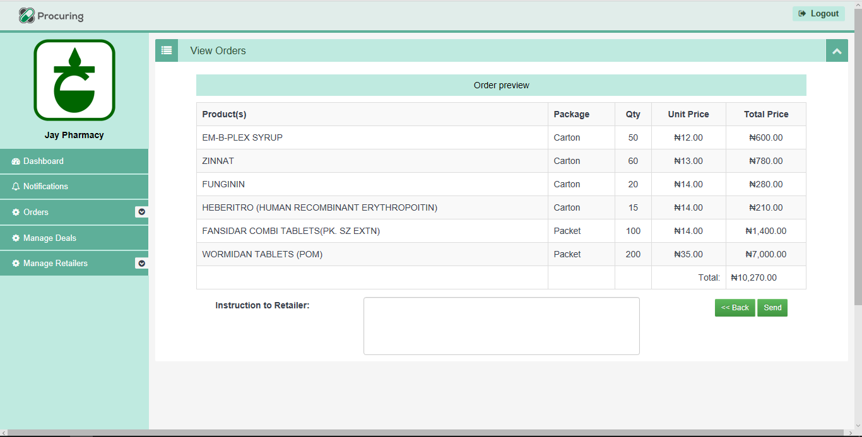

**Fig 3.10** Wholesaler/Supplier Edit Orders Page

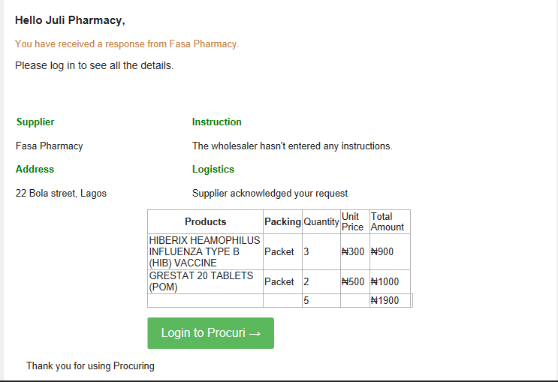

**Fig 3.11** Email Response from Wholesale/Supplier to Retailer

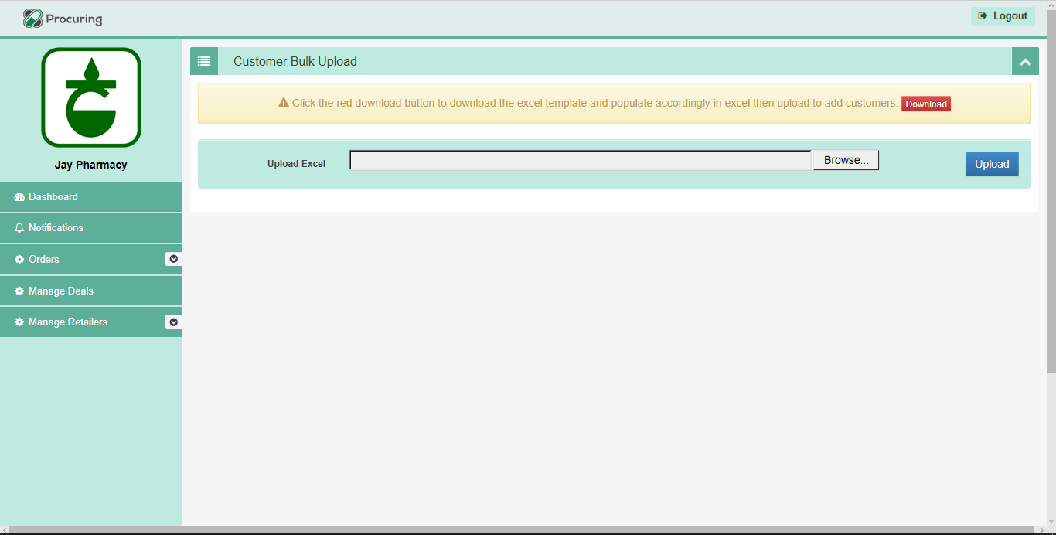

**Fig 3.12** Wholesaler/Supplier Retailer Bulk Upload Page

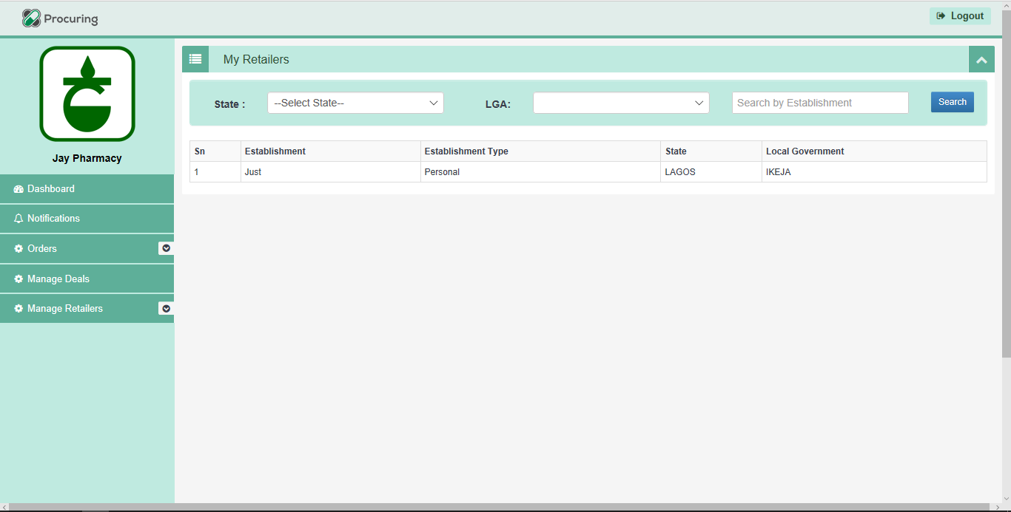

**Fig 3.13** Wholesaler/Supplier Retailer Page

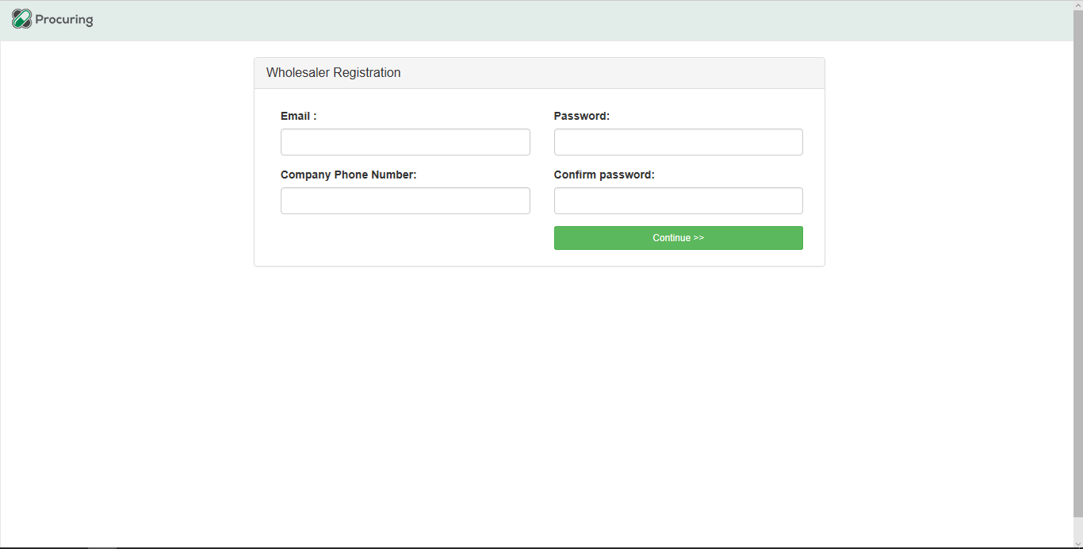

**Fig 3.14** Retailer Registration Page

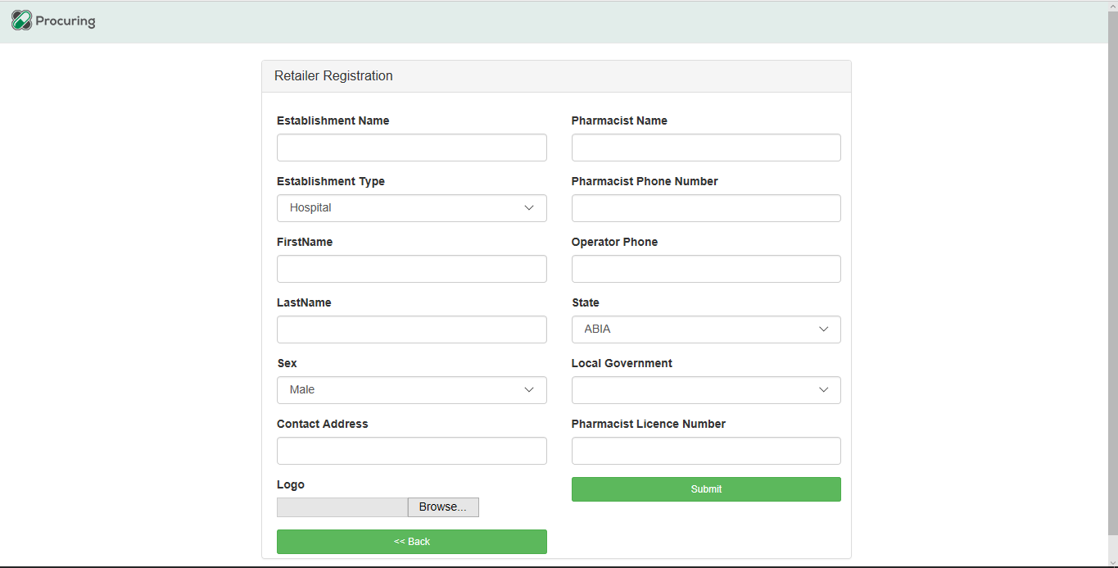

**Fig3.15** Retailer Registration Page Continued

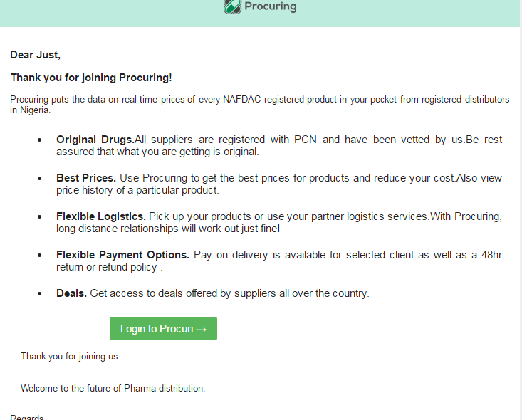

**Fig 3.16** Retailer Welcome Page (Email)

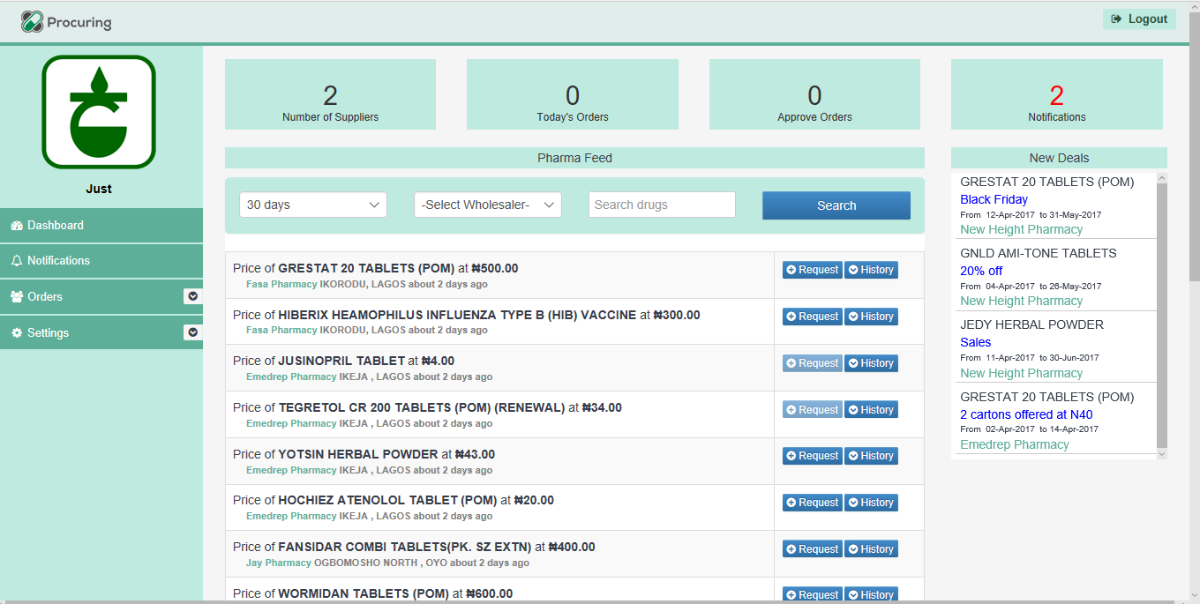

**Fig 3.17** Retailer Dashboard Page

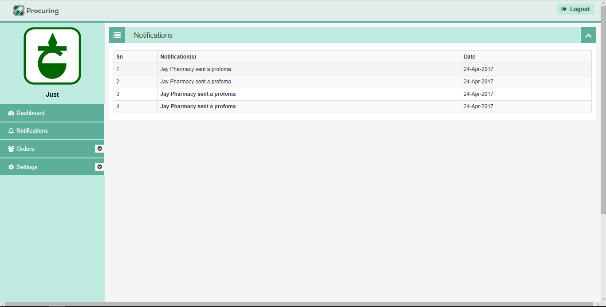

**Fig 3.18** Retailer Notifications Page

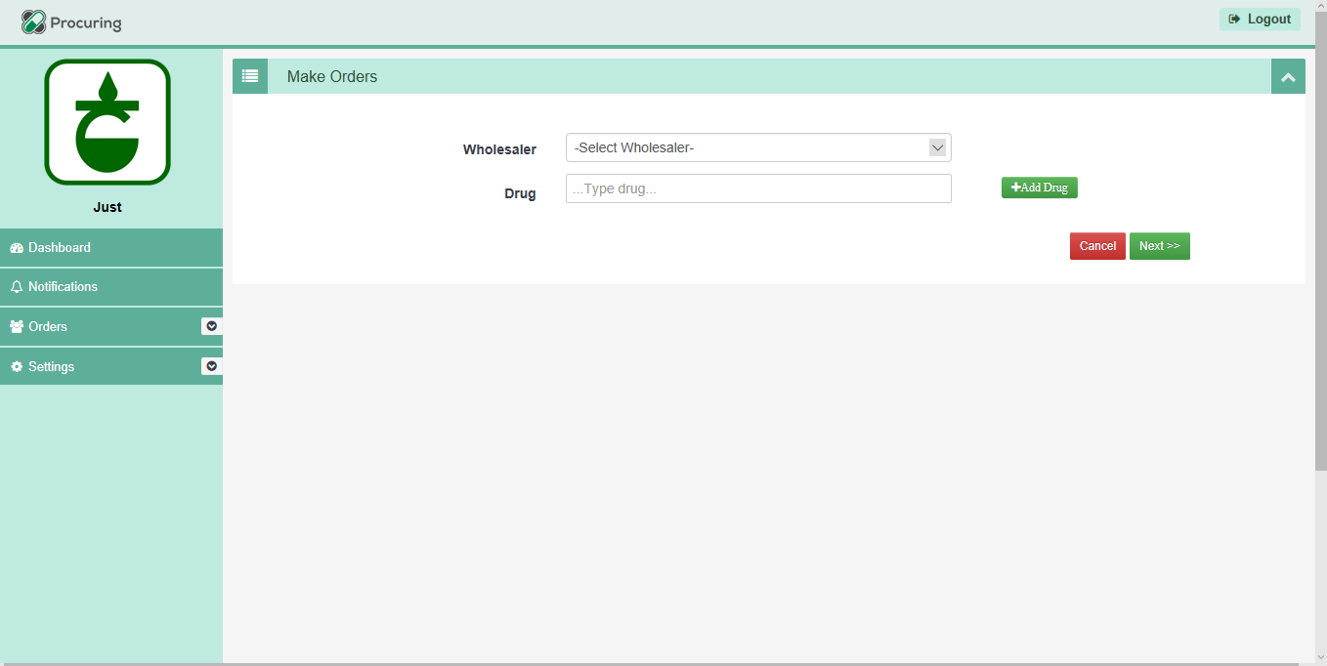

**Fig 3.19** Retailer Order Sheet Page

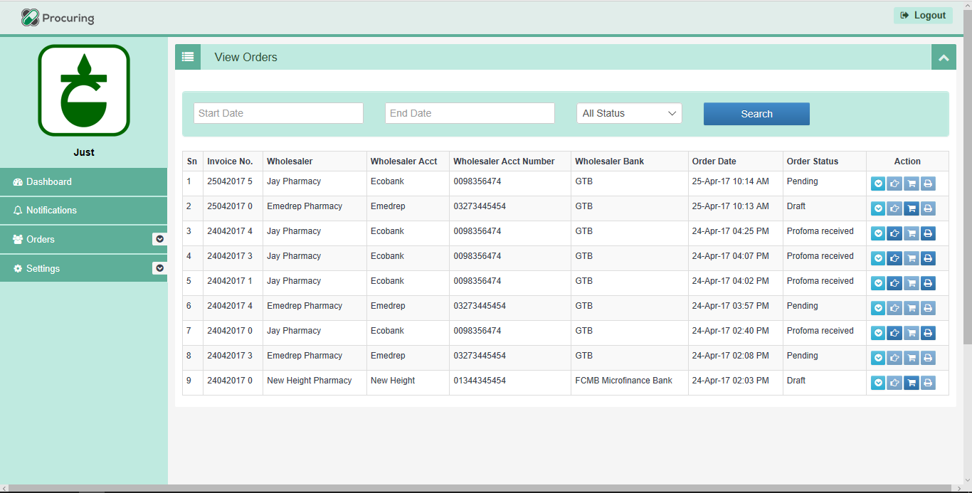

**Fig 3.20** Retailer View Orders Page

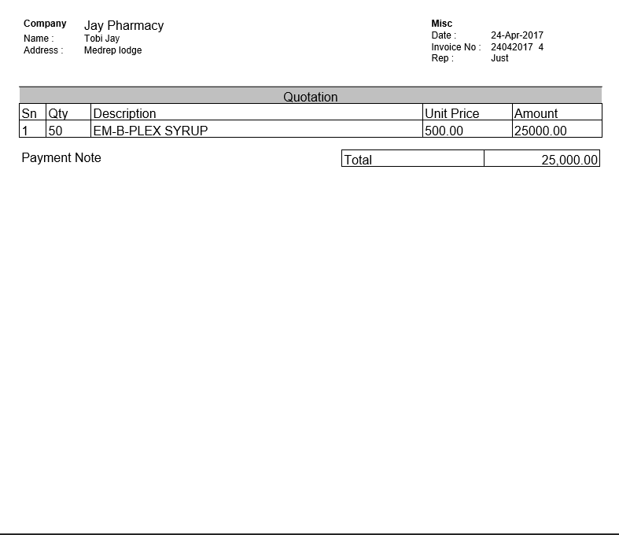

**Fig 3.21** Retailer Invoice Sample

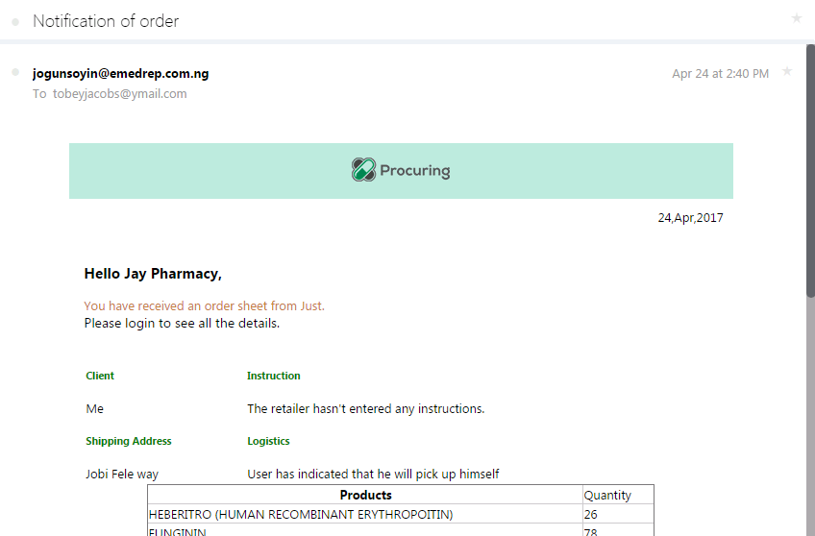

**Fig 3.22** Retailer Profoma Sample to Wholesaler/Supplier

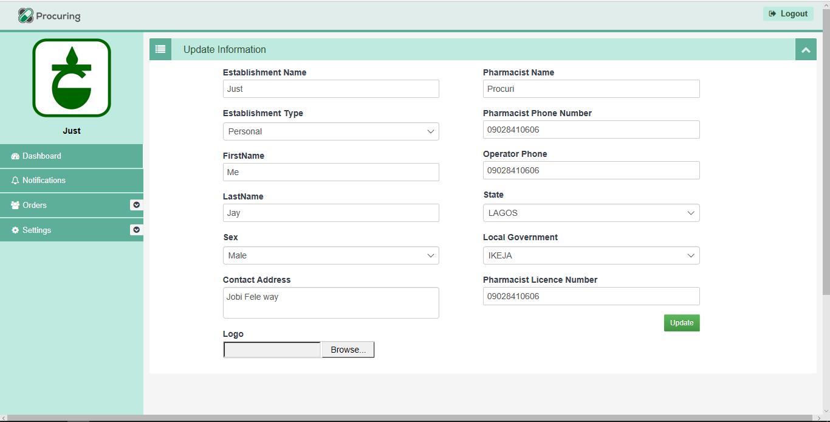

**Fig 3.23** Retailer Settings Page

* + - 1. Software Interfaces
* The software will need to interface with APIs to pull data from and push data updates into.
  + - 1. Communication Interfaces
* The software will link with other web services to conjure data.

1. **System Object Model**

**4.1 Introduction**

The System Object Model Section allows for a description of the subsystems in use. This allows for the description of the system totally to show the different grouping of parts into respective systems.

**4.2 Subsystems**

4.2.1The Administrative Module

4.2.2 The Wholesale Supplier Module

4.2.3 The Retail Supplier Module

4.2.4 Logistics Module

4.2.5 Payment Module

4.2.6 Notification Module

4.2.7

1. **Object Collaboration**

**5.1 Object Collaboration Diagram**

**5.1.1** This is a diagram depicting the object relationships.



**Fig. 5.1** eMedrep Collaboration Diagram

April 28, 2017

emedrep nigeria limited

Plot 15, Block J Alausa CBD Ikeja,Otunba Jobi Fele Way, Alausa.

1. **Data Design**

**6.1 Entity Relationship Diagram**

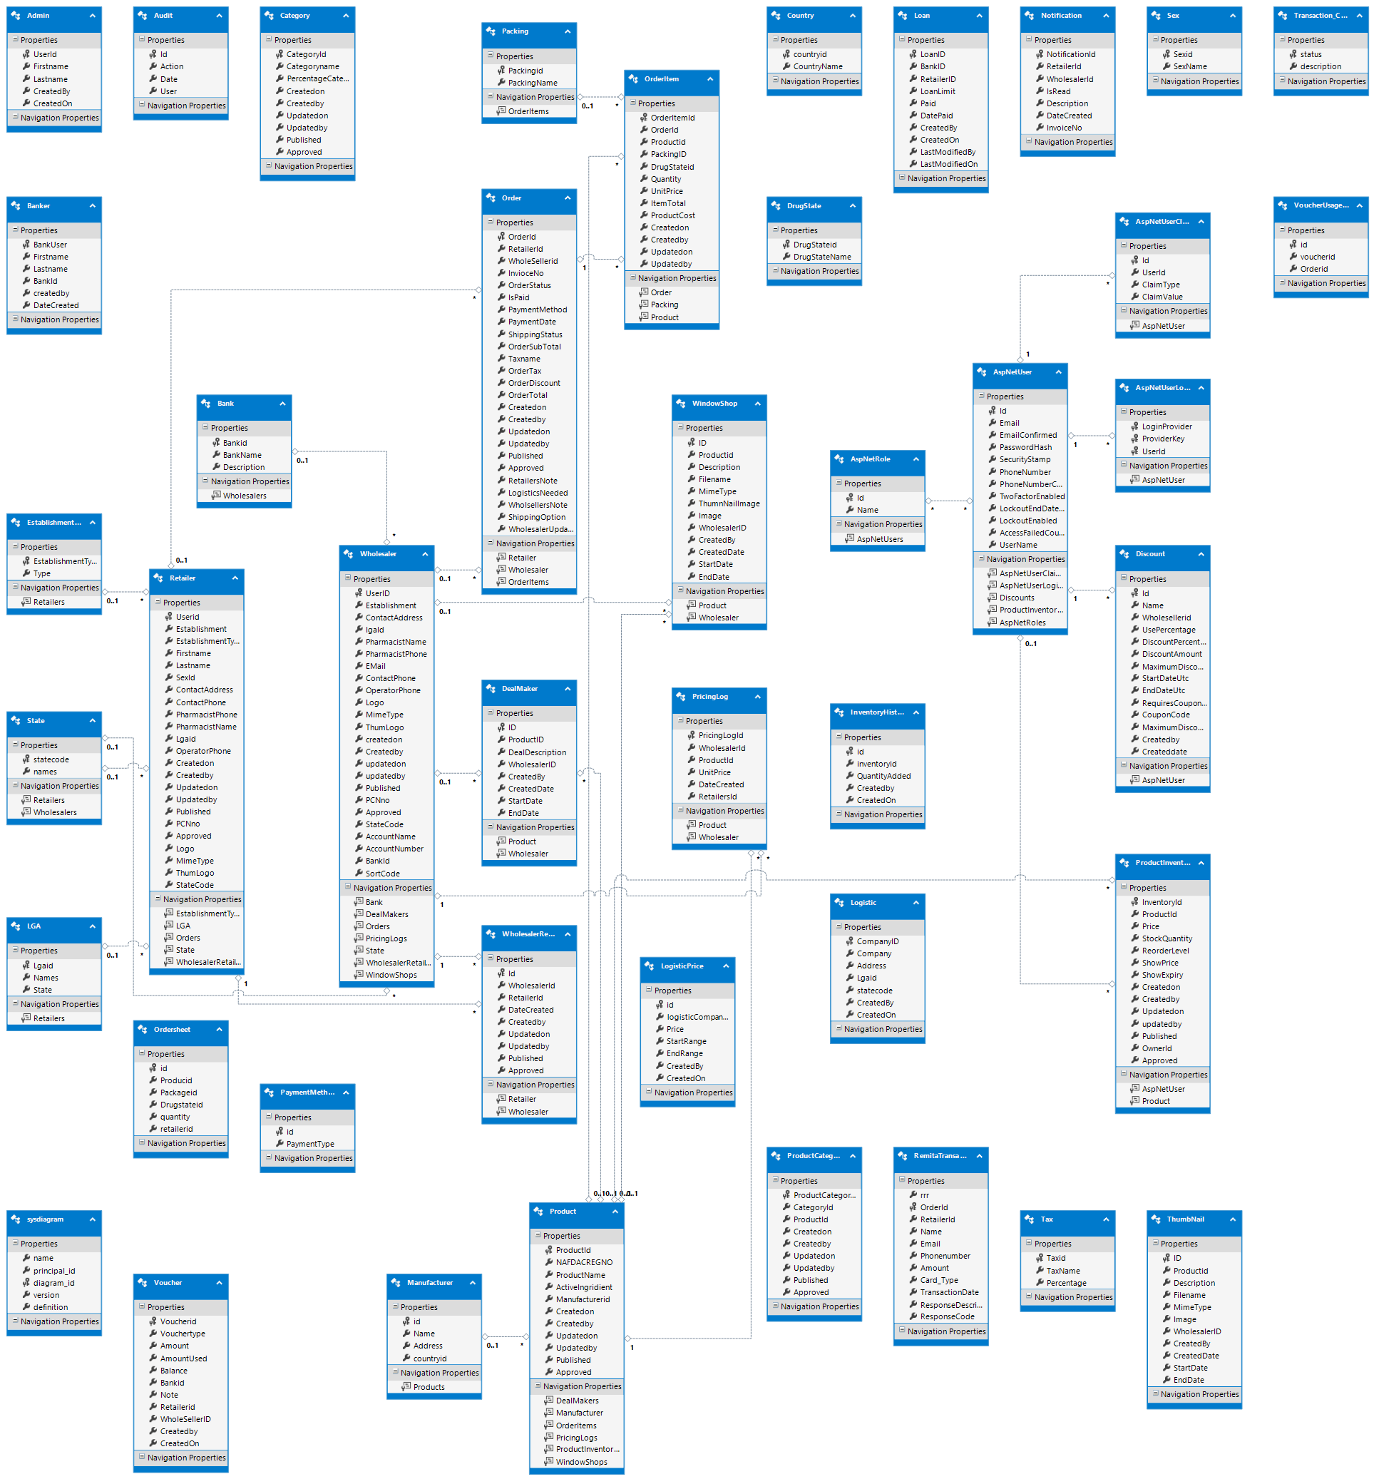

**Fig 6.1** Entity Designer Diagram

1. **Functional and Non-Functional Requirements**

**7.1 System Functional Requirements**

The behavior of the system was captured under the functional requirement. The eMedrep application has the following competences:

1. Registers Pharmaceutical institutions, both as wholesalers and retailers;
2. Allows for Wholesalers keep track of their retailers and their orders;
3. Eases and improves the mode of drug purchases;
4. Provides logistic and payment options for retailers;
5. Displays real time activity on drugs approved for sales;
6. Prompt notification on every order activity between wholesaler and retailer via mail and app;
7. Connects retailers, wholesalers, distributors and manufacturers nationwide;
8. Generates reports;
9. Integrated ad hoc reporting capacity that maintains user level security restrictions while allowing for user flexibility in choosing tables and fields as well as filtering and conditional report aspects;
10. Capacity to import and export data through XML and CSV and Excel formats while insuring a high accuracy of un-duplication rate.
11. Integrated technical safeguards to ensure a high level of privacy and security including back end server(s) – including data encryption and transmission; Administrator controlled username and password access; automatic log-off/timeout; Controlled user level read, write, edit and delete capabilities, user level module and sub-module access; Automated audit trail.
    1. **Specific Performance Requirements**
       1. **Accuracy and Validity**

The system will employ numerous data quality assurance techniques, including but not limited to:

* Input masks
* Drop down lists with standard responses
* Record data completeness requirements
* Basic data logic warnings
  + 1. **Timing**

The system will be available online 24hours per day, 365 days per week with the exception of scheduled and pre-notified system maintenance downtimes.

Data will become immediately available for use, both during input and reporting unless otherwise. System resources are adequate for timely report generation response times and overall software functionality. System and software updates and regular system maintenance is not completed during peak operation periods.

* + 1. **Capacity Limits**

eMedrep anticipates the daily input of client records, though no specific number of daily users utilizing the system concurrently nor client records can be mentioned yet. Peak usage timeframes are anticipated to be between 9:00am and 5:00pm daily.

* + 1. **System Description**

The proposed eMedrep system will consist of a web-based, centralized databased for client management and reporting. Generally, all users will provide direct input into the system and outputs (reports) will also be generated directly from the system. However, to ensure growth ability, flexibility is also required for both input and output modes.

* + 1. **System Integration**

An additional desired functionality of the system is system integration. eMedrep will be required to have the capacity to import and export data without ongoing support by the software vendor. The ability to customize and automate import and export utilities, with notifications highly prioritized. The import/export programming language must be either be open or a reliable and flexible data flexible transfer tool must be integrated with the software to facilitate the secure and reliable transfer of data between multiple and diverse external systems.

**7.3 Non-Functional Requirements**

This requirement of the system defines the system’s properties and the constraints **under which the system works. The system’s requirements such as reliability, portability and performance, etc. are assured with its security features that mitigate against unauthorized users. The system was developed on a web – programming platform that is most widely used called Active Server Page (ASP). Therefore, there are little or non-existent compatibility issues. The specified machines on which the programs run have quick response time.**

1. **Hardware Specification**

**Below are the minimum hardware requirements the application will be installed on.**

1. Processor: INTEL Pentium(R) Dual – Core CPU
2. RAM: 2GB
3. Hard Disk Drive: 120GB
4. Key Board: Standard 101/102
5. Monitor: Display Panel (1366 X 768)
6. Display Adapter: Trident Super VGA
7. Mouse: PS/2 Mouse, USB Mouse
8. **User Performance.**

**The structure of the application has been made with the advanced computer user and the novice in mind. The system is also robust for everyday use. An advanced user should at least use a day to become acquainted with the system. A novice who has some basis of computing should at least use a week or more to know the system.**

**8.0 Security**

**eMedrep software and hardware must meet the following minimum security requirements of Data and Technical Standards.**

**These requirements include:**

* System Security
* User Authentication
* Virus Protection
* Firewalls
* Public Access
* Physical Access to System with access to eMedrep data
* Disaster protection and recovery
* Disposal
* System monitoring
* Software Application Security
* User Authentication
* Electronic Data Transmission
* Electronic Data Storage
* Hard Copy Security
* Protection of hard copy generated by or for eMedrep that contains Personal Protected Information when the hard copy is in a public area.